Hotel Booking Cancellation Analysis Report

By safia mirbahar

1. Business Problem
City Hotel and Resort Hotel have been experiencing high booking cancellation rates. These cancellations lead to:
- Reduced revenue
- Underutilized rooms
The goal of this analysis is to identify factors influencing cancellations and provide actionable recommendations to reduce them and improve revenue efficiency.

2. Assumptions
- Data from 2015 to 2017 is representative and unaffected by unusual events.
- The data reflects current hotel booking trends.
- Suggested solutions can be safely implemented without negative consequences.
- Hotels are not currently using the recommended solutions.

3. Research Questions
- What factors influence hotel booking cancellations?
- How can cancellations be reduced?
- How can insights help hotels make better pricing and promotional decisions?
- How do cancellations impact hotel revenue and room occupancy?

4. Hypotheses
- Higher prices lead to more cancellations.
- Longer waiting times increase the likelihood of cancellations.
- Most bookings come through offline travel agents.

5. Data Analysis & Insights

6.1 Cancellation Rates
- City Hotel: 43% canceled
- Resort Hotel: 28% canceled
- Resort Hotel has ~35% lower cancellation rate than City Hotel

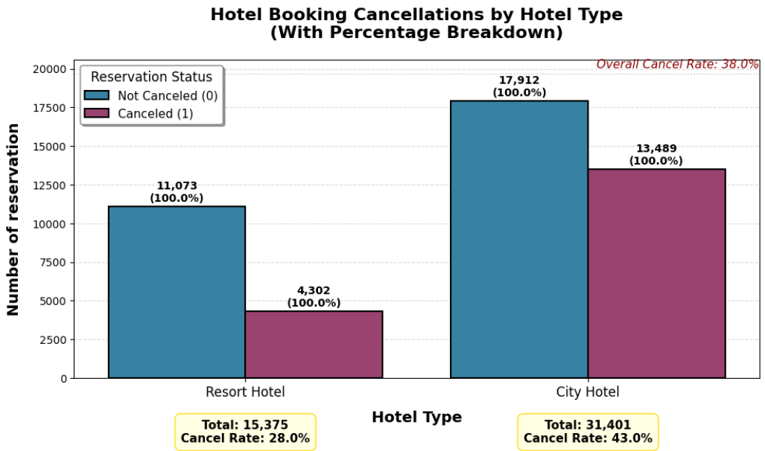

6.2 Monthly Booking Trends
- Highest cancellation months: February (43.8%), June (48.7%)
- Lowest cancellation months: August (27.9%), December (31.1%)

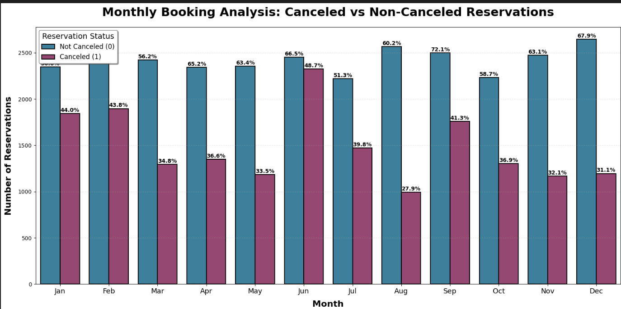

6.3 Revenue Impact (ADR of Canceled Bookings)
- Highest lost revenue: June ($235,182), September ($192,044)
- Lowest lost revenue: August ($115,003), November ($124,061)

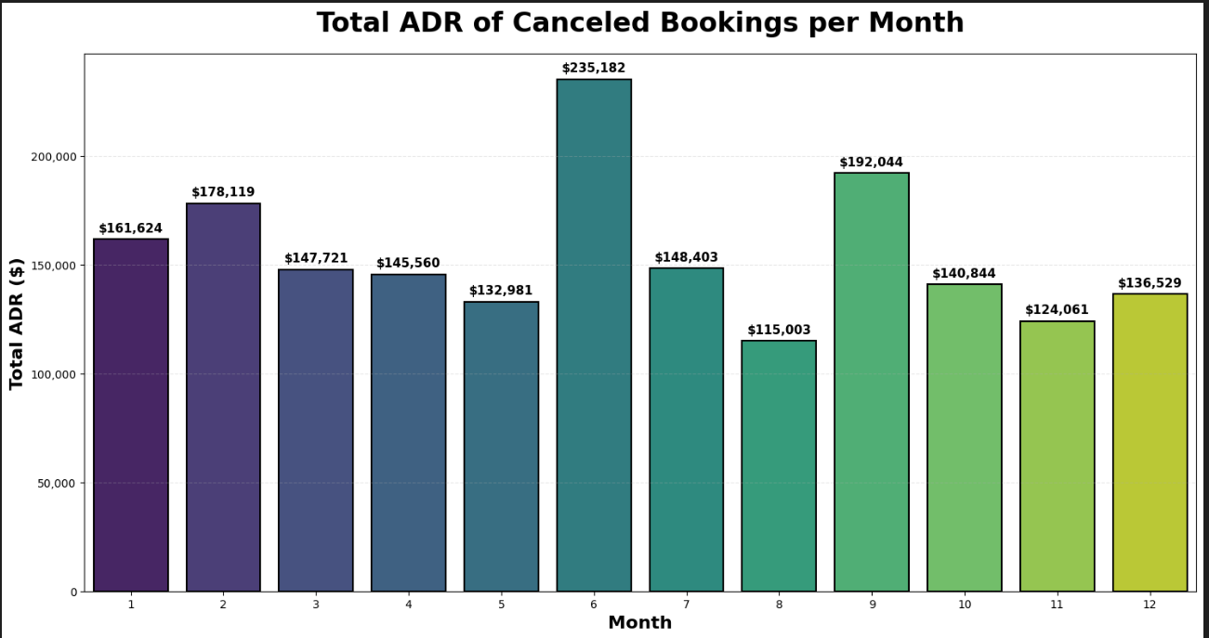

6.4 Top 10 Countries with Canceled Reservations
- Majority of cancellations from PRT (Portugal)
- 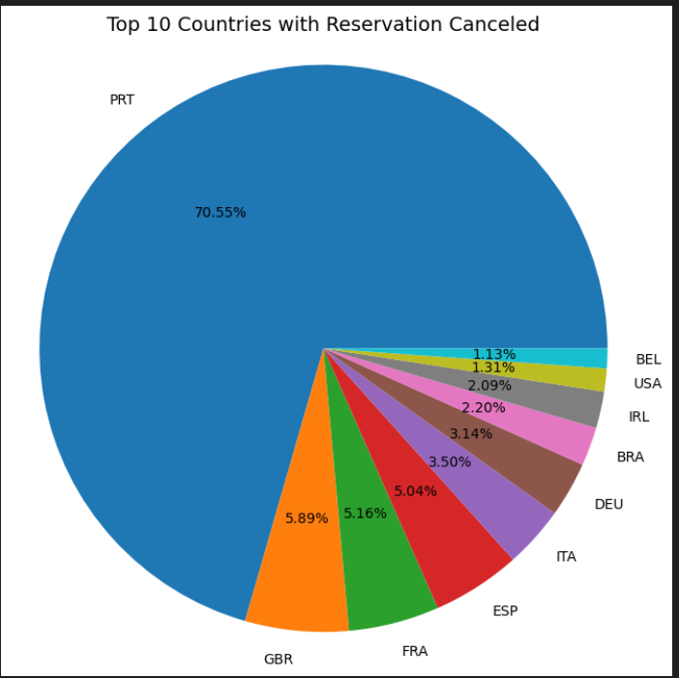

6.5 Booking Channel Analysis
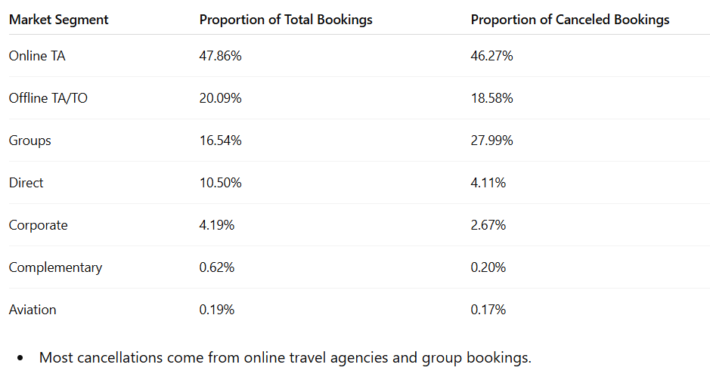

6.6 Price Analysis
- Resort Hotel Mean ADR: $100.74
- City Hotel Mean ADR: $103.07
- Canceled bookings are $13.65 more expensive on average than non-canceled bookings

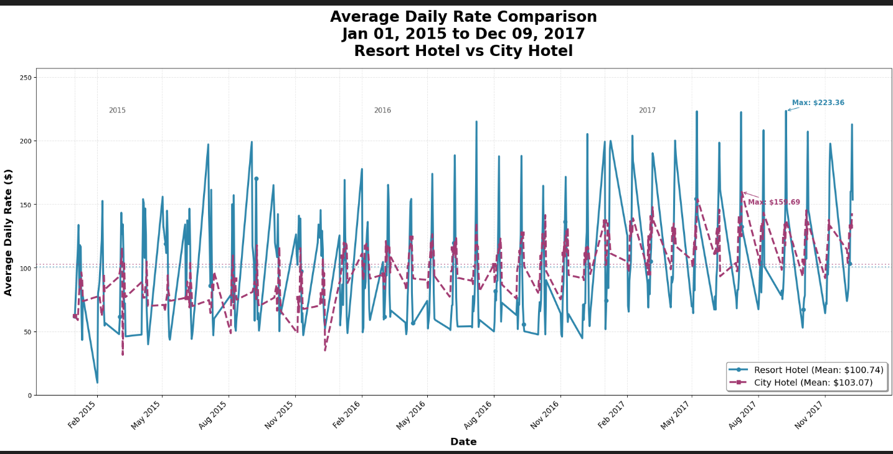

7. Recommendations
To reduce cancellations and improve hotel performance:
- Offer flexible pricing and discounts during months with high cancellations to encourage guests to keep their bookings.
- Enhance online booking management by sending reminders, confirmations, or easy rescheduling options to prevent last-minute cancellations.
- Focus marketing on group bookings and online travel agencies, since these segments have the highest cancellations. Tailored offers can reduce the risk.
- Incentivize early confirmations by providing perks like small discounts or added benefits for guests who confirm their stay in advance.

8. Conclusion
High cancellation rates affect both revenue and room occupancy. By focusing on smart pricing, better booking management, targeted promotions, and seasonal strategies, City Hotel and Resort Hotel can reduce cancellations, maximize occupancy, and increase overall revenue.

